Heaven’s Light is Our Guide
Rajshahi University of Engineering & Technology

Department of Electrical & Computer Engineering

Lab Manual
Computer Networks Sessional
ECE 4212
(0.75 Credit)

Lab Manuals have been developed for the requirements of course of ECE 3218

Department of Electrical & Computer Engineering
Faculty of Electrical & Computer Engineering
Rajshahi University of Engineering & Technology
Rajshahi-6204

ECE 4212
Computer Networks Sessional
Credit: 0.75
INDEX
SL No. | Experiment Name
01 | Study of different kinds of topologies and their simulations.
02 | Study of static routing configuration and simulation using cisco packet tracer.
03 | Study of RIP routing configuration and simulation using cisco packet tracer.
04 | Study of Static and RIP routing (floating) configuration and simulation using cisco packet tracer.
05 | Study of static routing configuration using VLSM technique and simulation using cisco packet tracer.

Experiment No: 01
Name of the Experiment: Study of different kinds of topologies and their simulations
Theory:
Computer networks interconnect multiple computing devices for data exchange. Various network devices such as hubs, switches, routers, bridges, and gateways perform distinct roles in communication. Common topologies include bus, star, ring, mesh, and hybrid — each offering trade-offs in performance, scalability, and fault tolerance.
Required Apparatus:

Experimental Steps:
(A) Switch Communication (Same Network)
SETUP:
Connect PC0, PC1 → Switch1
IP CONFIG:
PC0 = 192.168.10.1 / 255.255.255.0
PC1 = 192.168.10.2 / 255.255.255.0
TEST:
PING PC1 from PC0 → expect reply
(B) Router Communication (Different Networks)
SETUP:
Connect PC2 → Router(Fa0/0), PC3 → Router(Fa0/1)
IP CONFIG:
PC2 = 198.168.11.2 / 255.255.255.0, GW = 198.168.11.1
PC3 = 198.168.12.2 / 255.255.255.0, GW = 198.168.12.1
ROUTER:
Fa0/0 = 198.168.11.1 / 24
Fa0/1 = 198.168.12.1 / 24
TEST:
PING PC3 from PC2 → verify routing
(C) Star Topology
SETUP:
Connect PC4–PC7 → central Switch2
IP CONFIG:
192.168.13.1–192.168.13.4 / 255.255.255.0
TEST:
PING between all PCs → ensure full reachability
(D) Mesh Topology
SETUP:
Fully connect PC8–PC11
IP CONFIG:
192.168.14.1–192.168.14.4 / 255.255.255.0
TEST:
PING all-to-all → confirm mesh links
(E) Hybrid Topology
SETUP:
Router2 ↔ Switch1, Switch2; PCs on each switch
IP CONFIG:
Switch1 side: 198.168.13.2–.5, GW 198.168.13.1
Switch2 side: 198.168.15.2–.5, GW 198.168.15.1
ROUTER:
Fa0/0 = 198.168.13.1 / 24
Fa0/1 = 198.168.15.1 / 24
TEST:
PING PC4 ↔ PC12 → verify inter-switch routing

Diagram:

Result:

Discussion:

Experiment No: 02
Name of the Experiment: Study of static routing configuration and simulation using cisco packet tracer.
Theory:
Static routing is a type of network routing technique. Static routing is not a routing protocol; instead, it is the manual configuration and selection of a network route, usually managed by the network administrator. It is employed in scenarios where the network parameters and environment are expected to remain constant. Static routing, also referred to as non-adaptive routing, is a routing mechanism handled by the Internet Protocol (IP) and does not modify the routing table until manually modified by the network administrator. Since static routers do not exchange routing information with others, they must be configured and maintained independently. Static routing offers higher or greater security than dynamic routing because it does not require complicated routing algorithms.
Required Apparatus:
Experimental Steps:
• Opened Cisco Packet Tracer and selected PCs, routers, and switches.
• Assigned IP addresses and subnet masks to PCs and router interfaces.
• Added WAN interface cards to routers, configured serial links, and assigned serial IPs.
• Built the network topology and connected all devices.
• Configured each PC with its IPv4 address, subnet mask, and default gateway.
• Assigned static routes on all routers.
• Added network addresses, subnet masks, and next-hop information in the static routing menu.
• Finally, tested connectivity by sending messages between networks.

Diagram:
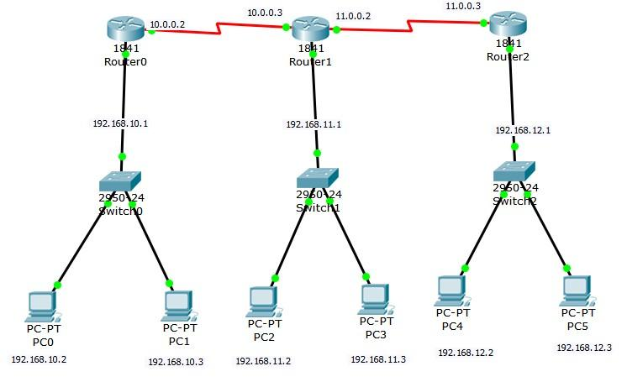
Data Table:
Table-1: IP addresses of PCs.
PCs | IP Address | Subnet Mask
PC0 | 192.168.10.2 | 255.255.255.0
PC1 | 192.168.10.3 | 255.255.255.0
PC2 | 192.168.11.2 | 255.255.255.0
PC3 | 192.168.11.3 | 255.255.255.0
PC4 | 192.168.12.2 | 255.255.255.0
PC5 | 192.168.12.3 | 255.255.255.0

Table-2: IP addresses of routers fast ethernet and serial port.
Ports | IP Address | Subnet Mask
Router0 (fast ethernet) | 192.168.10.1 | 255.255.255.0
Router0 (serial 0/0/0) | 10.0.0.2 | 255.0.0.0
Router1(fast ethernet) | 192.168.11.1 | 255.255.255.0
Router1(serial 0/0/0) | 10.0.0.3 | 255.0.0.0
Router1(serial 0/0/1) | 11.0.0.2 | 255.0.0.0
Router2(fast ethernet) | 192.168.12.1 | 255.255.255.0
Router2 (serial 0/0/0) | 11.0.0.3 | 255.0.0.0

Static Routing address of router0
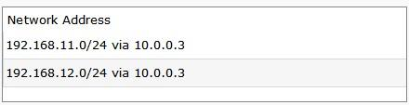
Static Routing address of router1
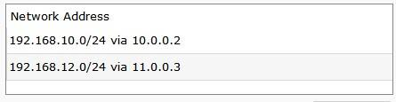
Static Routing address of router2
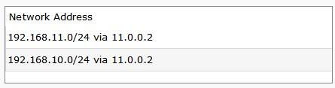
Successfully message exchanging between PCs.
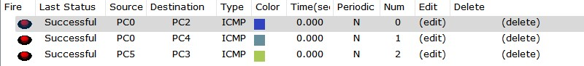

Discussion:

Experiment No: 03
Name of the Experiment: Study of RIP routing configuration and simulation using cisco packet tracer.
Theory:
The Routing Information Protocol (RIP) is a distance vector protocol that routers use to exchange information about available routes in a local area network. Routers using RIP send periodic update messages to other routers in the network and when the network topology changes. These updates allow a router to learn the network topology and calculate the best path to a destination network. When a router receives routing information from another router, it updates its local routing table and sends a RIP update containing the revised routing table to its neighboring routers. The router stores only the best path to a destination in its routing table. RIP uses a hop count to calculate the best path. The best path is the path that has the fewest number of hops (routers) that packets must traverse to reach the destination network. The maximum number of hops allowed in a path in a RIP network is 15 hops. The Sun Secure Application Switch supports RIP v1 and RIP v2.
Required Apparatus:

Experimental Steps:
• Opened Cisco Packet Tracer and selected PCs, routers, and switches.
• Assigned IP addresses and subnet masks to all PCs and router interfaces.
• Added WAN interface cards to routers, configured serial links, and set serial IPs.
• Built the network topology and connected devices using automatic cables.
• Configured each PC with its IPv4 address, subnet mask, and default gateway.
• Configured routing on all routers.
• Enabled RIP routing and added all network addresses to every router.
• Finally, tested connectivity by sending messages between networks.
Diagram:
Data Table:
Table-1: IP addresses of PCs.
PCs | IP Address | Subnet Mask
PC0 | 192.168.10.2 | 255.255.255.0
PC1 | 192.168.10.3 | 255.255.255.0
PC2 | 192.168.11.2 | 255.255.255.0
PC3 | 192.168.11.3 | 255.255.255.0
PC4 | 192.168.12.2 | 255.255.255.0
PC5 | 192.168.12.3 | 255.255.255.0

Table-2: IP addresses of routers fast ethernet and serial port.
Ports | IP Address | Subnet Mask
Router0 (fast ethernet) | 192.168.10.1 | 255.255.255.0
Router0 (serial 0/0/0) | 10.0.0.2 | 255.0.0.0
Router1(fast ethernet) | 192.168.11.1 | 255.255.255.0
Router1(serial 0/0/0) | 10.0.0.3 | 255.0.0.0
Router1(serial 0/0/1) | 11.0.0.2 | 255.0.0.0
Router2(fast ethernet) | 192.168.12.1 | 255.255.255.0
Router2 (serial 0/0/0) | 11.0.0.3 | 255.0.0.0

RIP Routing address for all routers
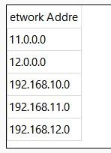
Successfully message exchanging done between PCs.
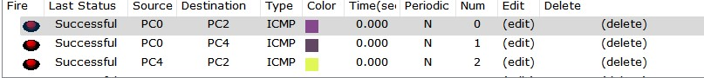

Discussion:

Experiment No: 04
Name of the Experiment: Study of Static and RIP routing (floating) configuration and simulation using cisco packet tracer.
Theory:
Static Routing: Static routing is a type of network routing technique. Static routing is not a routing protocol; instead, it is the manual configuration and selection of a network route, usually managed by the network administrator. It is employed in scenarios where the network parameters and environment are expected to remain constant. Static routing, also referred to as non-adaptive routing, is a routing mechanism handled by the Internet Protocol (IP) and does not modify the routing table until manually modified by the network administrator. Since static routers do not exchange routing information with others, they must be configured and maintained independently. Static routing offers higher or greater security than dynamic routing because it does not require complicated routing algorithms.
RIP Routing: The Routing Information Protocol (RIP) is a distance vector protocol that routers use to exchange information about available routes in a local area network. Routers using RIP send periodic update messages to other routers in the network and when the network topology changes. These updates allow a router to learn the network topology and calculate the best path to a destination network. When a router receives routing information from another router, it updates its local routing table and sends a RIP update containing the revised routing table to its neighboring routers. The router stores only the best path to a destination in its routing table. RIP uses a hop count to calculate the best path. The best path is the path that has the fewest number of hops (routers) that packets must traverse to reach the destination network. The maximum number of hops allowed in a path in a RIP network is 15 hops. The Sun Secure Application Switch supports RIP v1 and RIP v2.
Required Apparatus:
Experimental Steps:
(A) Network Design
CREATE 3 routers (Router0–Router2) and 5 PCs
CONNECT routers serially (R0↔R1↔R2) using serial links
CONNECT PCs to routers via switches
(B) Subnet Planning using VLSM
CALCULATE subnet requirements for 40, 22, and 2 hosts
ASSIGN subnet addresses:
192.168.10.0/26 → 64 addresses
192.168.10.64/27 → 32 addresses
192.168.10.96/30 → 4 addresses
192.168.10.100/30 → WAN1
192.168.10.104/30 → WAN2
(C) IP Configuration
ASSIGN IPs to PCs according to respective subnet ranges
CONFIGURE routers’ FastEthernet and Serial interfaces with correct subnet IPs and masks
ENABLE routing protocol (RIP) on all routers
SAVE configuration
(D) Testing & Verification
PING between PCs across subnets
VERIFY router routing tables using show ip route
OBSERVE data transfer through VLSM-enabled links
Diagram:
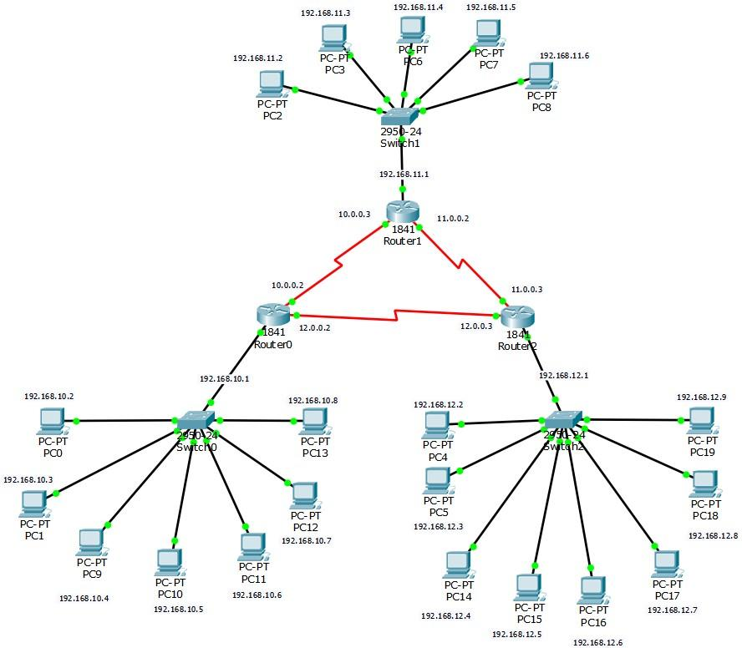
Data Table:

Static Routing
- Opened Cisco Packet Tracer and selected PCs, routers, and switches.
- Assigned IP addresses and subnet masks to all PCs and router interfaces.
- Added WAN interface cards, configured serial links between routers, and assigned serial IPs.
- Built the network topology and connected all devices.
- Configured each PC with its IPv4 address, subnet mask, and default gateway.
- Opened each router’s Static Routing menu and added routes by specifying network address, subnet mask, and next-hop IP.
- Tested end-to-end connectivity by sending messages between networks.

RIP Routing
- Used the same topology and device configurations (IP addressing, serial links, and PC setup).
- Opened each router’s RIP Routing configuration.
- Added all existing network addresses to enable automatic route sharing through RIP.
- Verified successful routing by sending messages between different networks.

Discussion:

Experiment No: 05
Name of the Experiment: Study of static routing configuration using VLSM technique and simulation using cisco packet tracer.
Theory:
Variable Length Subnet Mask (VLSM) is a method used in IP network design to create subnets with varying subnet masks. By allowing different subnet sizes, VLSM enables network administrators to allocate IP addresses more efficiently, using smaller subnet masks for subnets with fewer hosts and larger masks for those with more hosts. Unlike traditional subnetting, where a fixed subnet mask is applied to all subnets, VLSM provides greater flexibility, reducing IP address waste. It is commonly used in modern networks to optimize IP address usage and allows subnets of different sizes. VLSM can also be described as the process of further subnetting an existing subnet.
Required Apparatus:
Experimental Steps:
• Prepared the VLSM table based on the given network requirements.
• Designed the network in Cisco Packet Tracer using the required number of PCs and routers.
• For large host groups, used IP gaps to reduce the number of simulated PCs.
• Assigned IP addresses and subnet masks to PCs and routers using the VLSM table.
• Added WAN interface cards to routers, configured serial links, and assigned serial IPs.
• Configured each PC with its IPv4 address, subnet mask, and default gateway.
• Opened the Static Routing menu on each router and added routes (network, subnet mask, next hop).
• Tested connectivity by sending messages between networks.
Testing & Verification
PING between PCs across subnets
VERIFY router routing tables using show ip route
OBSERVE data transfer through VLSM-enabled links
Diagram:

v

Host C

hosts
14

Host B

hosts
25

h
8
osts

Host
D

27
hosts

Host A

Data Table:
Table-1: VLSM routing IP address Table.
Subnet mask | Host  Number | Host  bit | Network  Address/CIDR | First Usable Address | Last Usable Address | Broadcast Address | Subnet Mask
A | 27 | 5 | 172.31.103.0/27 | 172.31.103.1 | 172.31.103.30 | 172.31.103.31 | 255.255.255.224
B | 25 | 5 | 172.31.103.32/27 | 172.31.103.33 | 172.31.103.62 | 172.31.103.63 | 255.255.255.224
C | 14 | 4 | 172.31.103.64/28 | 172.31.103.65 | 172.31.103.78 | 172.31.103.79 | 255.255.255.240
D | 8 | 4 | 172.31.103.80/28 | 172.31.103.81 | 172.31.103.94 | 172.31.103.95 | 255.255.255.240
WAN | 2 | 2 | 172.31.103.96/30 | 172.31.103.97 | 172.31.103.98 | 172.31.103.99 | 255.255.255.252

Table-2: IP addresses of routers fast ethernet and serial port.
Ports | IP Address | Subnet Mask
Router0 (fast ethernet 0/0) | 172.31.103.1 | 255.255.255.224
Router0 (fast ethernet 0/1) | 172.31.103.33 | 255.255.255.224
Router0 (serial 0/0/0) | 172.31.103.97 | 255.255.255.252
Router1(fast ethernet 0/0) | 172.31.103.65 | 255.255.255.240
Router1(fast ethernet 0/1) | 172.31.103.81 | 255.255.255.240
Router1(serial 0/0/0) | 172.31.103.98 | 255.255.255.252

Static Routing address of router0
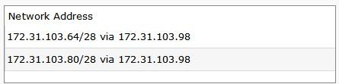
Static Routing address of router1
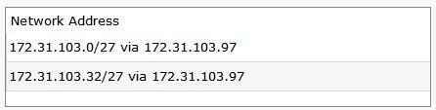
Successfully message exchanging between PCs.
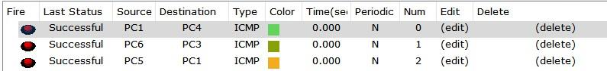

Discussion:

